Enhancement to Eprocurement

- Remarks Column in PR
- Separate Requestor Remarks (Internal View) from Delivery Information.

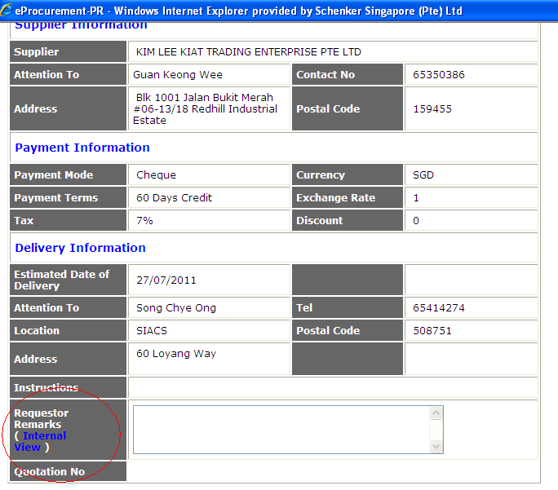
- A Separate line to be created for Requestor Remarks and worded as shown:

Requestor Remarks (Internal View only)

Fill in reason for no competitive quotes or other remarks

- Prevent Users from saving their PR if they do not attach enough quotations for Non-Standard items.
- If no quotation is attached at all.
  - Do not allow user to save
  - POP up box tell user to upload quotation. At least 1 quotation for value less than 2k, 2 quotation for value >2-5k, 3 quotations for value >5k
  - Once quotation attached, allow user to save
- If only 1 quotation for value > $2k - $5k.
  - Do not allow user to save,
  - POP up box tells user that they need 1 more quotation otherwise, fill up reason under Requestor Remarks
  - Once remarks completed by user, allow user to save
- If less than 3 quotations for value >$5k
  - Do not allow user to save,
  - POP up box tells user they need 3 quotations otherwise fill up reason under Requestor Remarks
  - Once remarks completed by user, allow user to save

- Regarding the POP up box and the selections available to the user (Monopoly, Time Sensitive, Business related, Customer Preferred)
- Please remove the drop down option list (we want users to fill up the remarks field instead of choosing reason from drop down list)

- Create a History List for the Supplier Listing (similar to History list in Product Listing)
- See screen capture below

